**Dan Schumacher, hdd249**

DA 6823

Kilger

Module 3: Part #1 (20 points)

**Statistical Significance Versus Effect Size + Independent Samples t test**

Here is the SAS printout for an independent samples ttest that compares advertising receptivity (scale =person has low ad receptivity, 5=person has high ad receptivity) between males (gender=1) and females (gender=0).

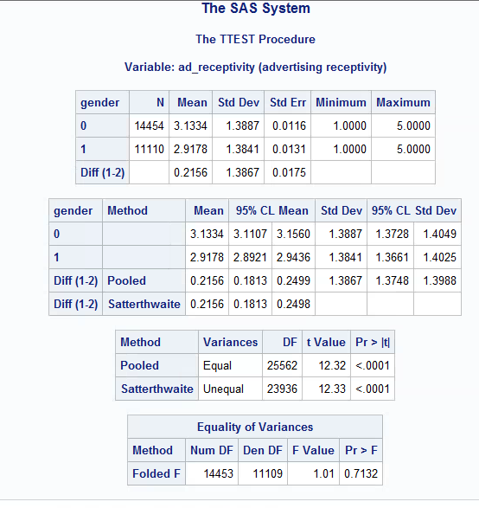

1. State the null and alternative hypotheses for the 2 independent sample t test. (4 points)
   1. **H0: mean group1 == mean group2**

**Halt: mean group1 != mean group2**

* 1. **H0: mean females == mean males**

**Halt mean females != mean males**

1. Name two assumptions of the 2 independent sample t test. ( 4 points)
   1. **Dep Var is at least interval.**
   2. **Dep Var is normally distributed.**
2. What is the mean ad receptivity for males? For females? (2 points)
   1. **Females: 3.1334**
   2. **Males: 2.9178**
3. Does the data suggest that the variance of ad receptivity in males versus females is to be treated as equal or unequal? What is the p value for this test? ( 4 points )
   1. **Using this portion of the chart, we can tell that our p value is 0.7132. This means that the variance of ad receptivity in males versus females is to be treated equally.**

1. What can you conclude about the differences in ad receptivity between males and females? Given the differences in the data between males and females, explain why you were able to come to the conclusion that you did. (6 points)
   1. A screenshot of a computer

      Description automatically generated
   2. **Because our variances are treated equal, we can use pooled variance. We see that our p value is <.0001 meaning we reject H0 and accept Halt. The mean female ad receptivity is not equal to the mean male ad receptivity.**